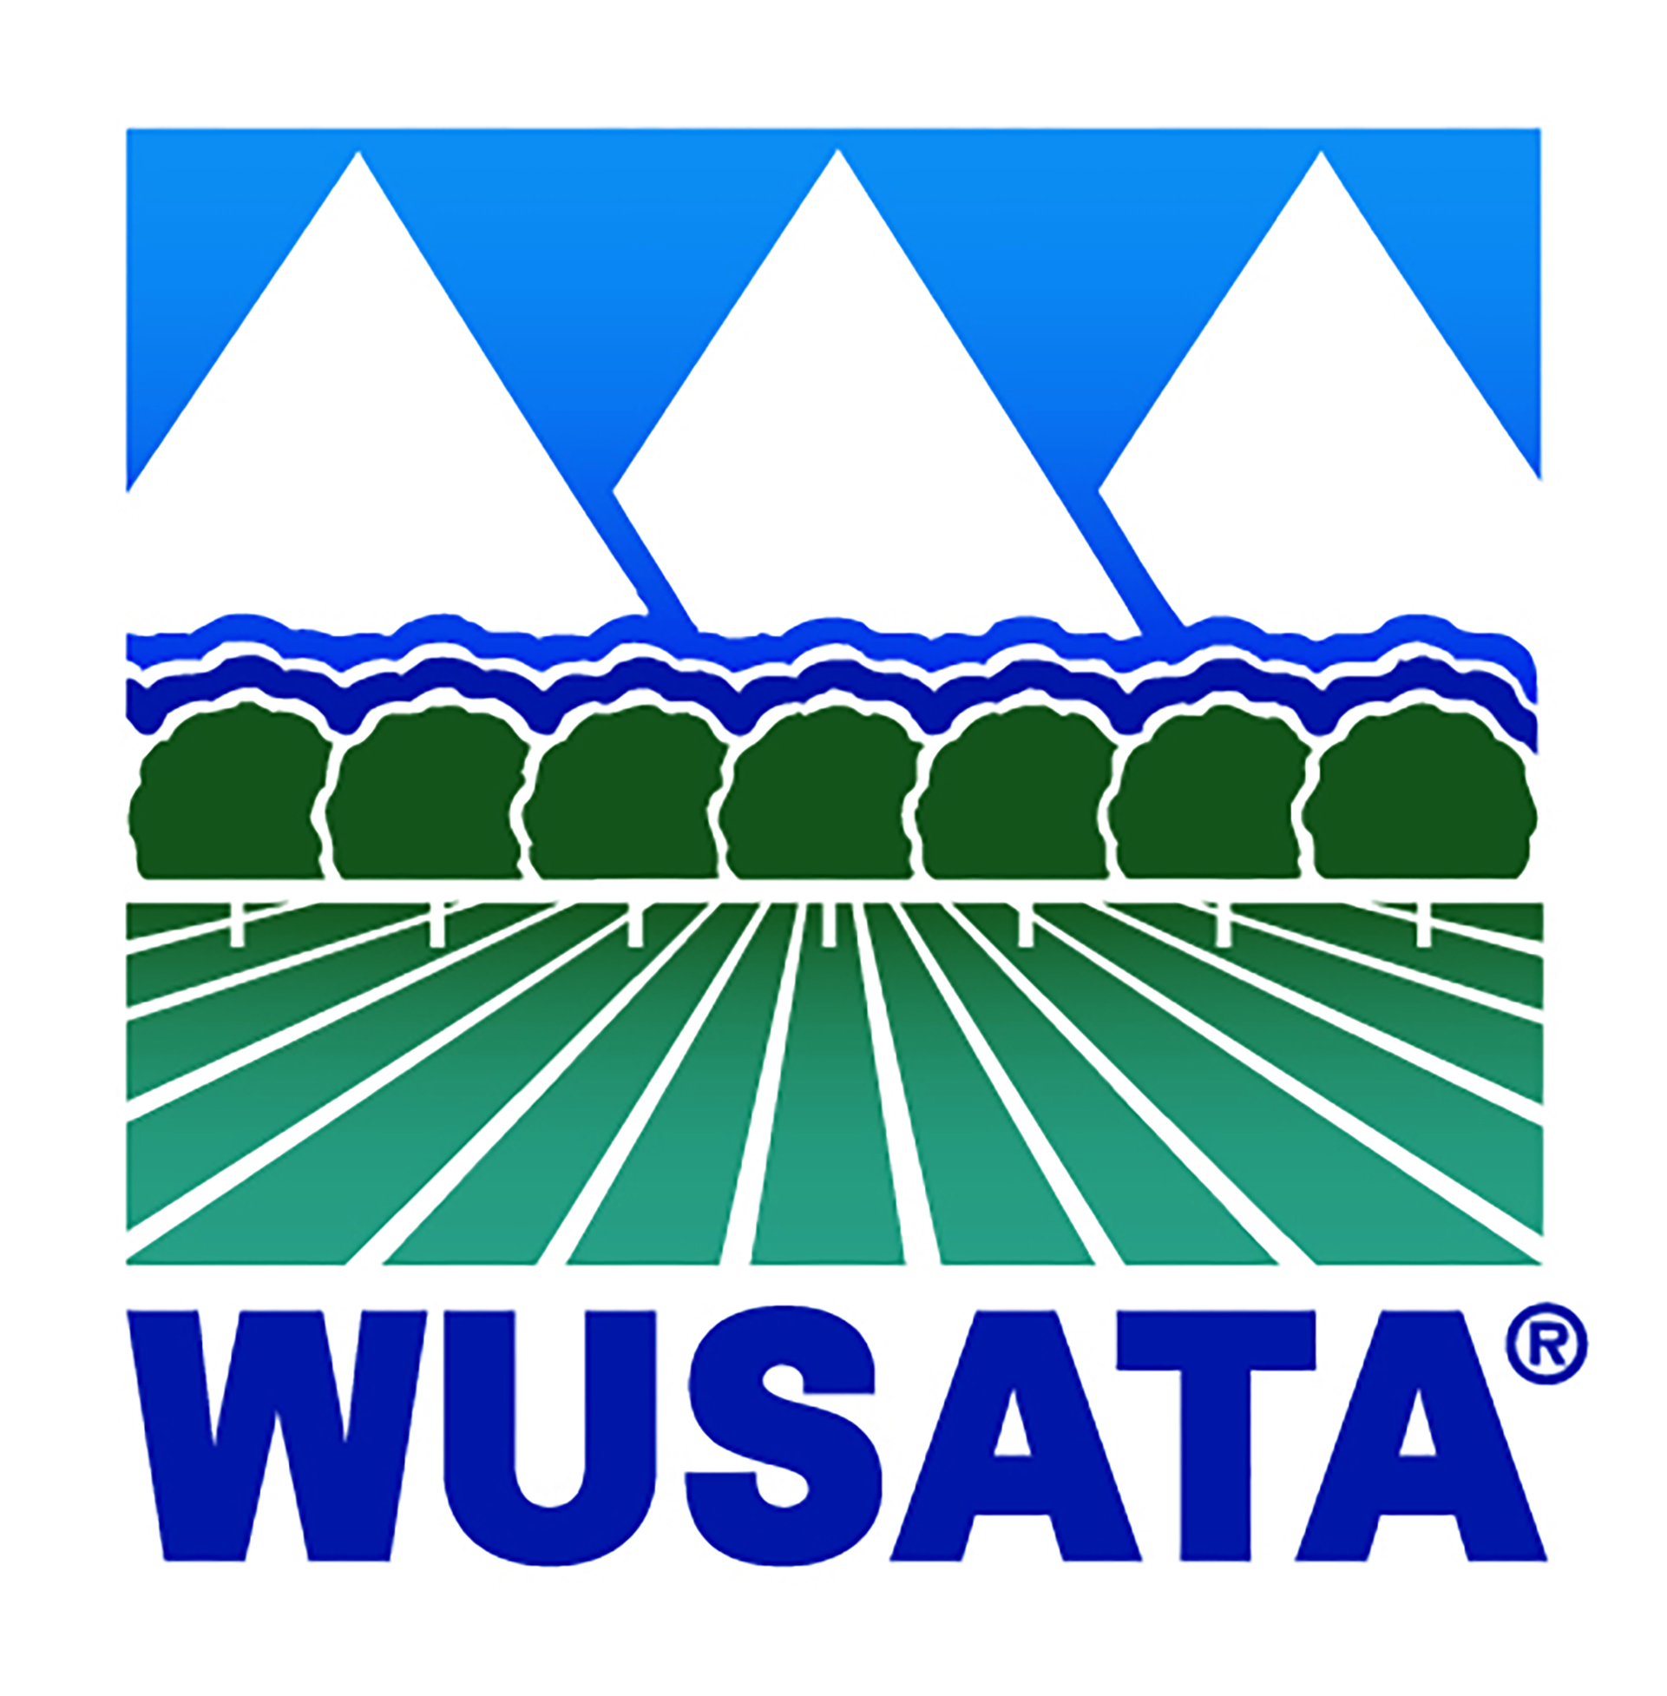

TRAVEL NOTIFICATION
2022 WUSATA FundMatch Program

Claims seeking international travel reimbursement must include a travel notification.

Only one travel notification is required for each international trade show/mission activity claim.

IMPORTANT:
- Company representatives traveling to foreign trade show/trade missions are required to notify the Foreign Agricultural Service (FAS) office located in the destination country in writing at least 14 business days prior to travel.
- Failure to provide advance notification of travel may result in disallowance of travel expense.
- Confirmation that the travel notification was sent must be submitted with all travel claims (Printed fax confirmation and/or sent email).

To find your destination country, please refer to the complete list of overseas Agricultural Trade Offices and U.S. Embassies here.

Attention: Agricultural Trade Office (ATO)/ Agricultural Attaché
Travel Destination Country:
FAS Post Fax Number: | FAS Post Email Address:
Traveling Company Name:
Traveling Company Phone: (if using a cell phone while in country, please include)

Traveler 1: (Name and Title) |  | Traveler 2: (Name and Title)
Name of Trade Show/Mission:
Dates of Travel:
Comments or Questions for Overseas Office:

