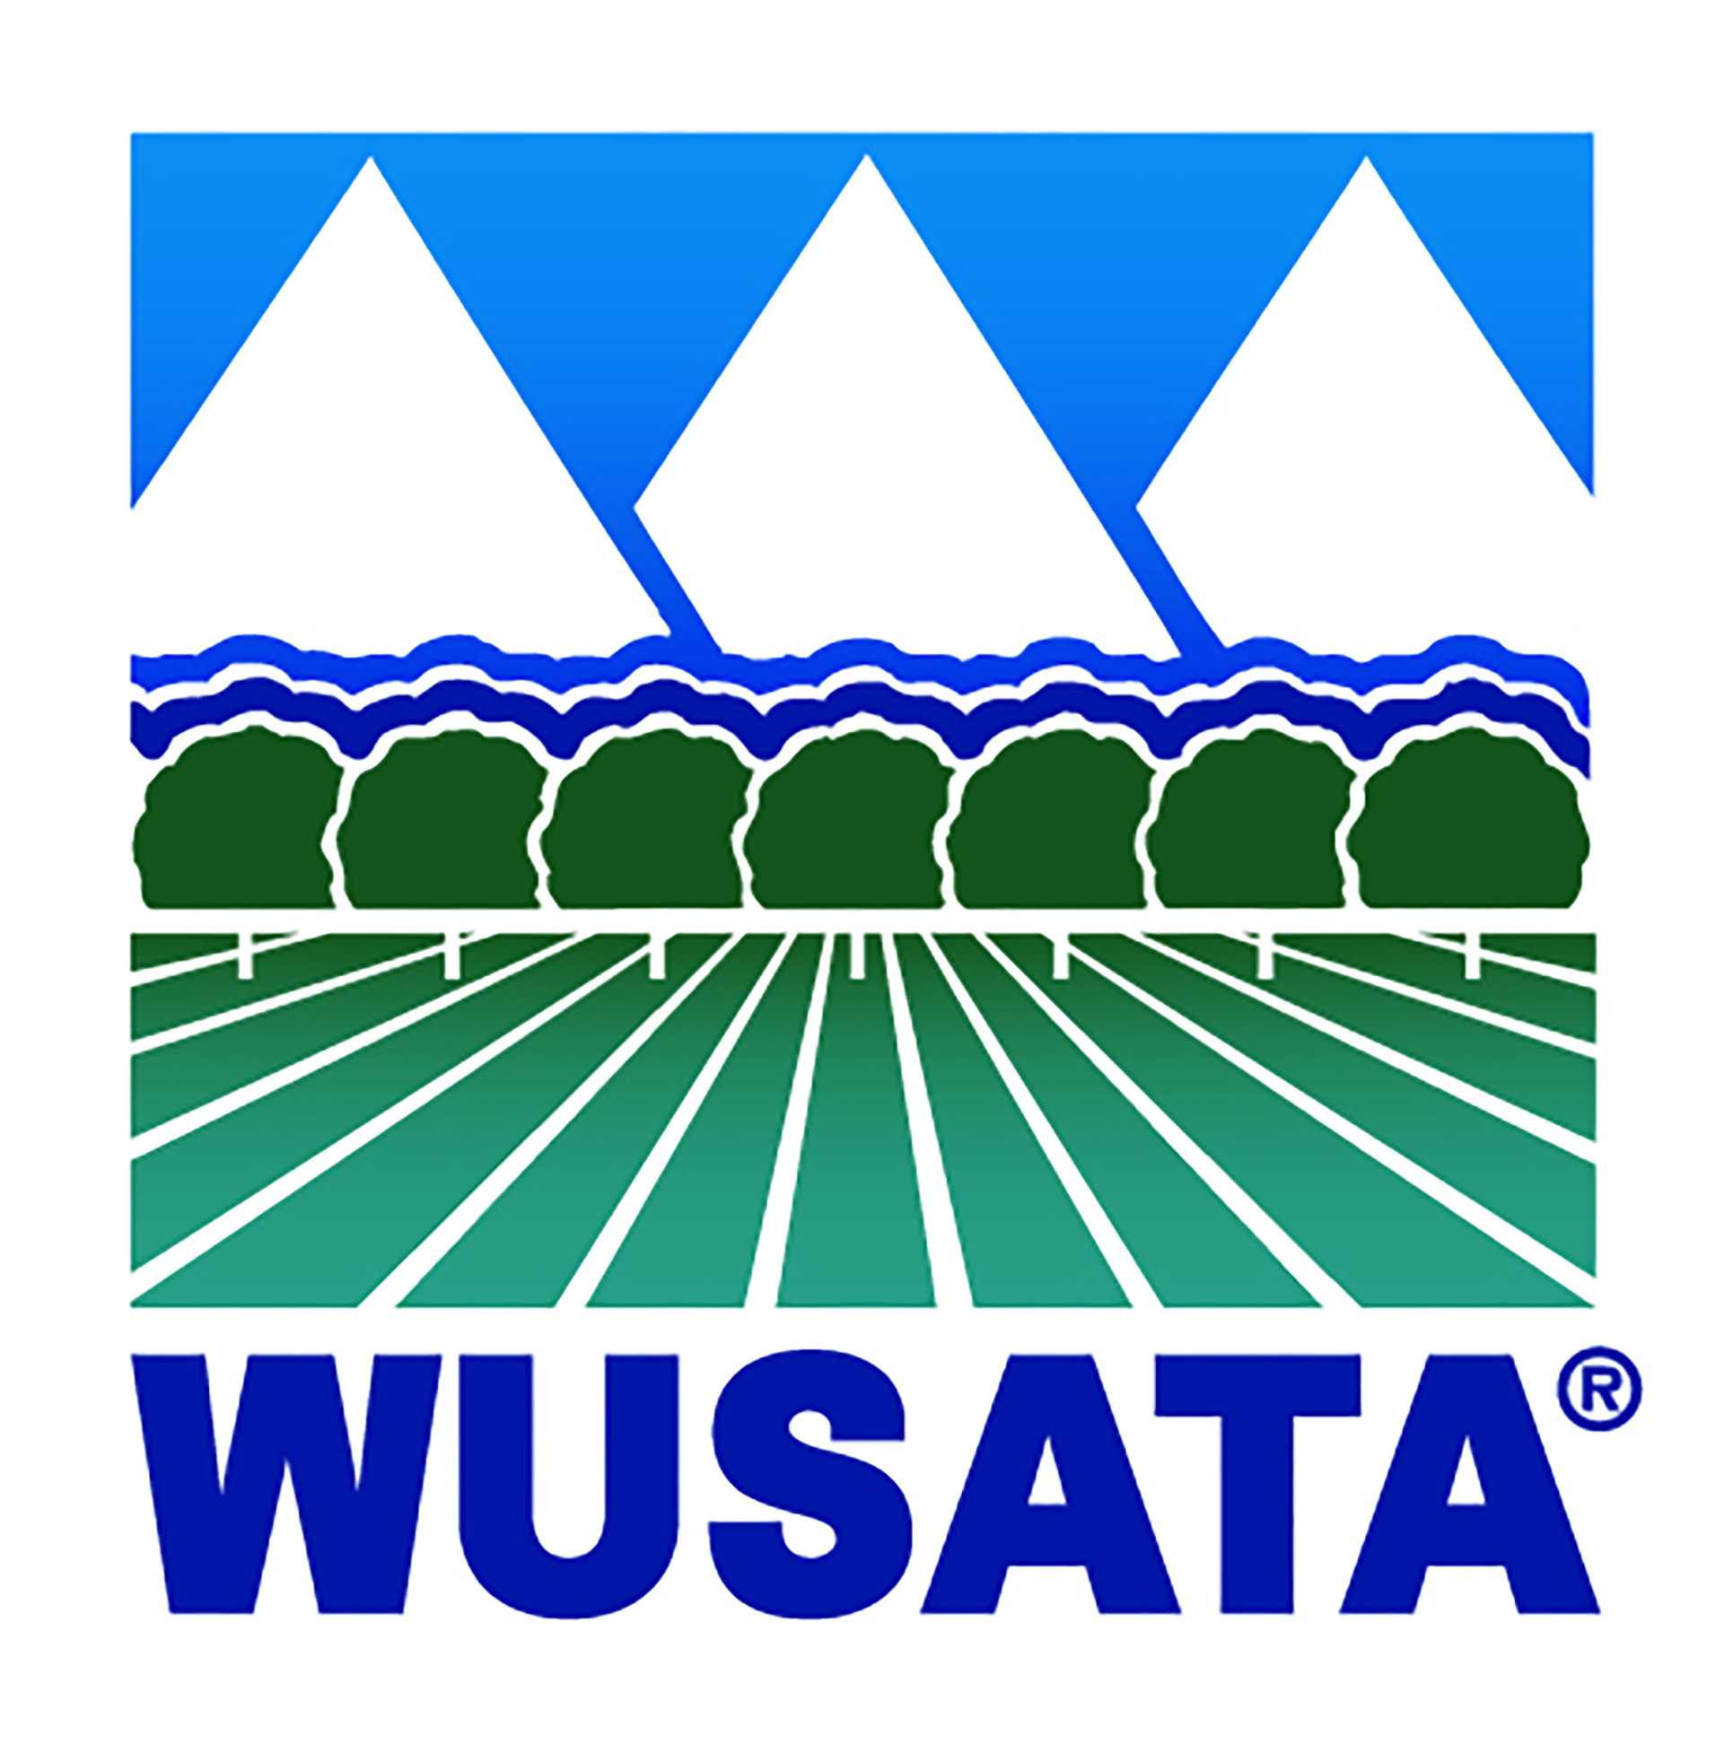
PRIVATE LABEL AGREEMENT
2021 WUSATA FundMatch Program

This form is for WUSATA FundMatch Program participants that are providing product(s) for private label usage. Please have the brand owner complete the form below.

I hereby certify that (WUSATA FundMatch Participant)
is the sole supplier for the following private label(s) and product(s), and that the product is grown in the USA:
Brand Name | Product

This agreement is valid for the following target markets:
Country | Country

Attention Brand Owners: This form confirms that the private label items promoted by WUSATA’s FundMatch Program participant are at all times manufactured with product farmed, fished or forested in the USA.

Brand Owner |  | WUSATA FundMatch Program Participant
Signature: |  | Signature:
Name: |  | Name:
Title: |  | Title:
Company: |  | Company:
Date: |  | Date:
Phone: |  | Phone:
Email: |  | Email:
This agreement is valid for MAP FundMatch Program Marketing Year 2021.

